**Key Features**

Type-C

Form Factor

USB 3.1

Interface

400MB/s Seq. reads

256GB

Capacity

• USB Type C Drive has transfer speeds up to 4GB in as little as 11 seconds.  
  
• Multi-proof protection against water, shock, magnet, temperature and X-ray.

Storage

**64GB**

$13.99

**128GB**

$17.99- Current Price$20.99- original price

**Save $3.00**

**256GB**

$26.99- Current Price$34.99- original price

**Save $8.00**

**512GB**

$54.99- Current Price$64.99- original price

**Save $10.00**

**VIP Advantage**

**VIP Advantage membershipLearn more**

* 2 Year Samsung Care+ (without Theft and Loss)
* Exclusive Discounts & Early Access

To select this option, please sign in or create a Samsung account

**Premium Benefits**

**$149.99/yr**

**Delivery & professional services**

Availability for:

10001

Delivery

**Delivery**

Not available



**In-Store Pickup**

Not available

**Choose your purchase option**

Questions? Ask a Financing Expert

**One-time Payment**

**$26.99**

**Pay in 4 Installments**

**$6.75**

**every two weeks σπ**

**One-time payment**

Pay with your credit card, debit card or a pay app. Excludes taxes and shipping.

**USB Type-C™ Flash Drive 256GB (MUF-256DA/AM)$26.99**

**Total**

**$26.99 $34.99- original price**

**You Saved Today$8.00**



**Log in now to earn up to 1.5% back in Samsung Rewards Points**

**Add to cart**

[**Where to buy**](https://www.samsung.com/us/computing/memory-storage/usb-flash-drives/usb-type-c-256gb-muf-256da-am-buy)

Supported payment types:

adyen_cardsPayPal Venmo Checkoutamazonpaygooglepay

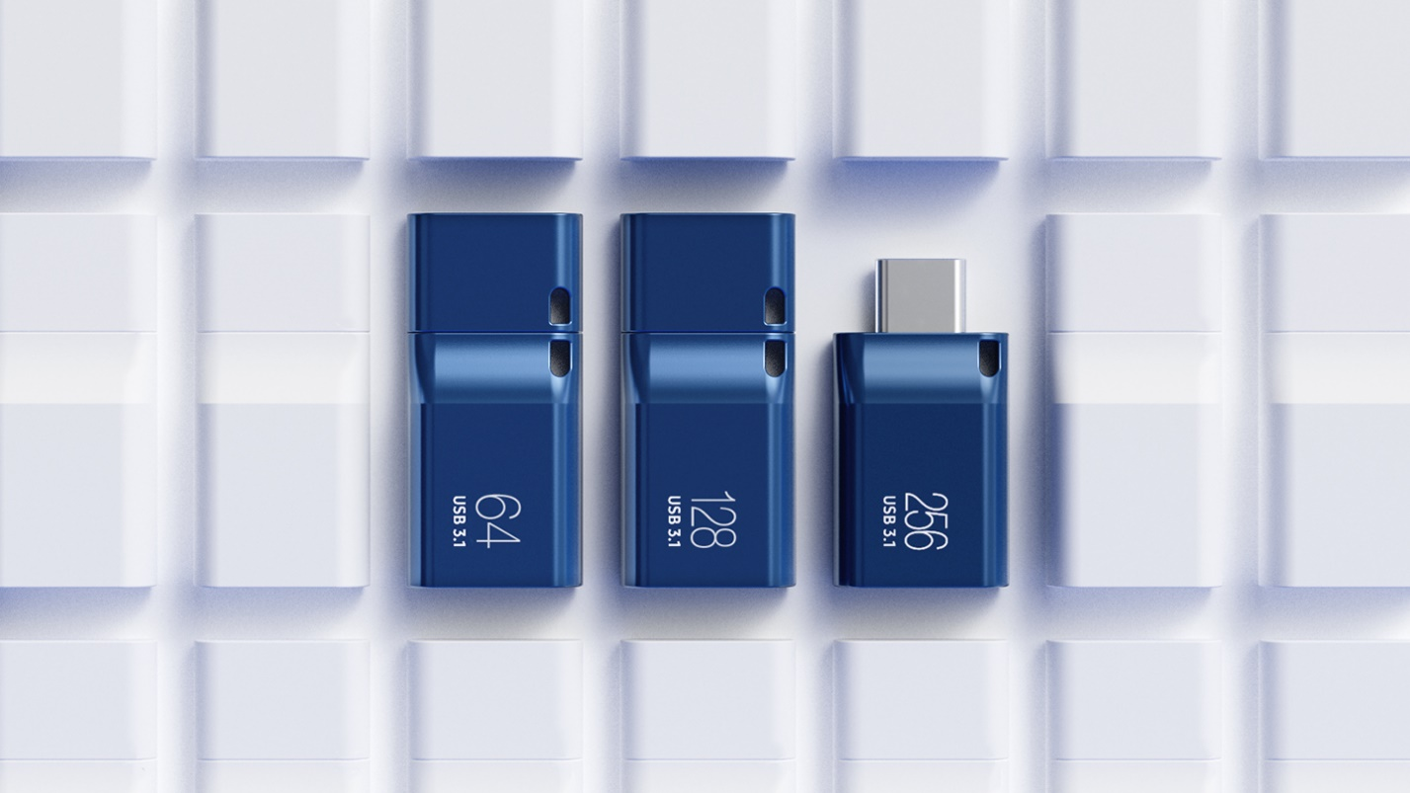

**USB-C storage  
on the go**

This sleek drive is supported by Samsung NAND flash, and is incredibly compact to fit in the palm of your hand. Count on reliable performance and fast transfer speeds while staying compact.

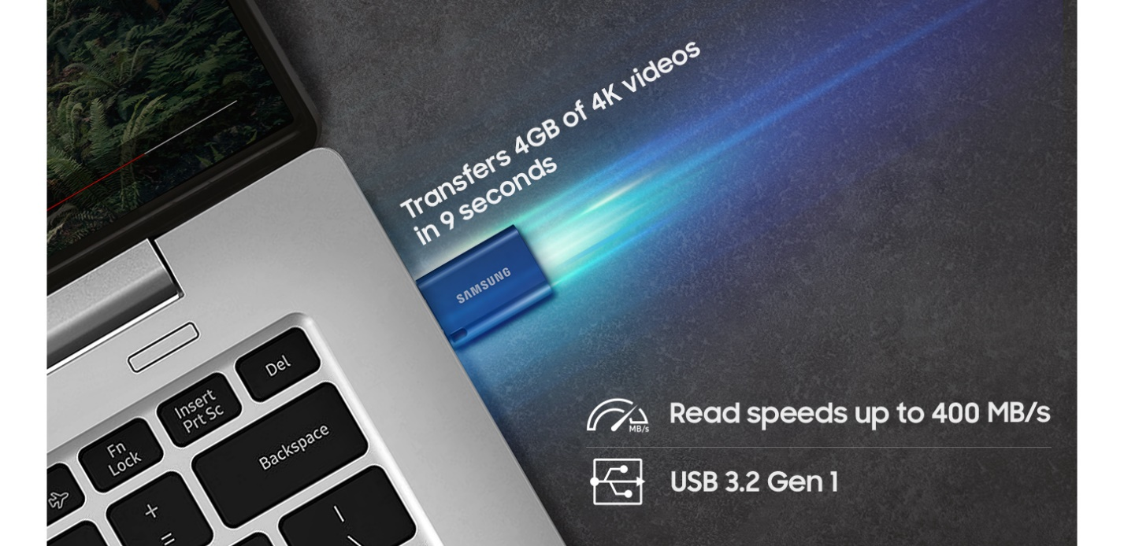

**Performance with speed**

No need to choose between performance and reliability. Experience a fast, powerful flash drive that transfers 4GB files in as little as 11 seconds¹ with up to 400MB/s² USB 3.13 read speeds\* that is backward compatible with USB 3.0/2.0.

*¹ Minimum of 11 secs for 256/128GB models, minimum of 15 secs for 64GB models (tested with combination of HP OMEN, Intel Core i7-10750H@2.60GHz, 8GB and Windows 10 Home 64bit).  
\* Actual speed may vary by host device and/or usage conditions.  
² Up to 400MB/s for 256/128GB models, up to 300MB/s for 64GB models. 3 USB 3.1 is equivalent to USB 3.2 Gen 1.*

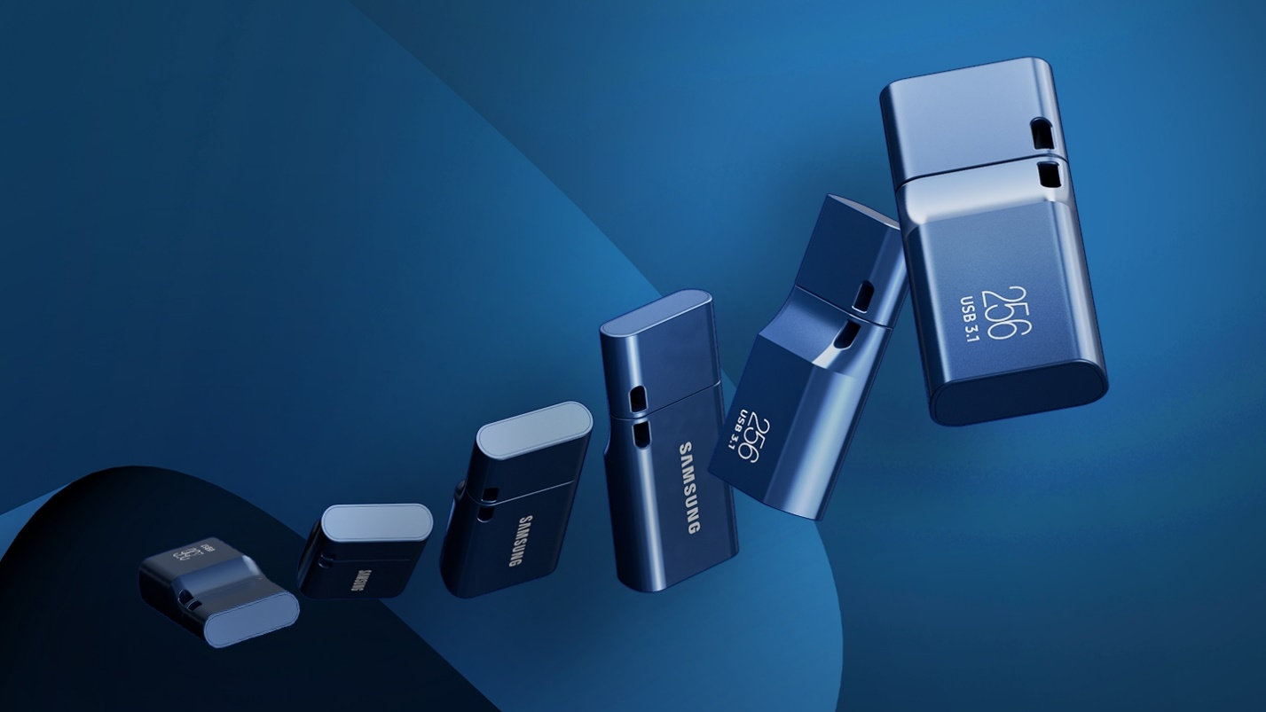

**Modern meets iconic**

The ultra-sleek USB drive looks as good as it performs. Featuring a the Type-C™ plug inserts into your devices seamlessly every time. Transfer large files with style and ease.

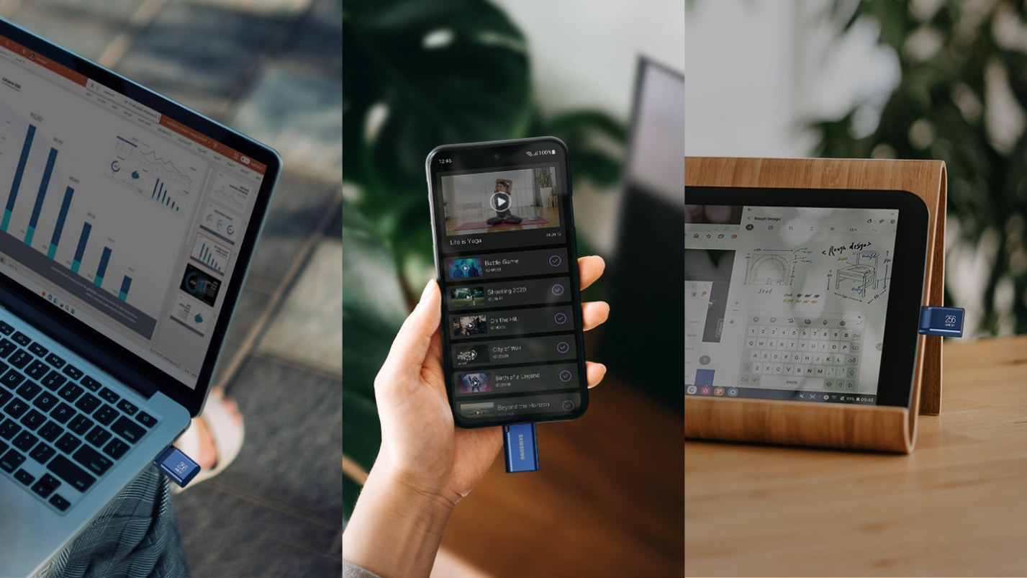

**Always connected**

Compatible with USB-C devices, including laptops, tablets, smartphones and cameras, with enough space for 63,730 photos¹ or maximum 12 hours of 4K video.²\*  With up to 256GB of storage space, this pocket-sized drive comes in handy wherever you go.

Vghu